**Project Report**

**on**

**STUDY BUDDY**

**Submitted as partial fulfillment for the award of**

**BACHELOR OF TECHNOLOGY**

**DEGREE**

**Session 2021-22**

**in**

**Computer Science and Engineering**

**By**

**STUDENT NAME: Satwik**

**Roll Number: 1803210134**

**STUDENT NAME: Vrinda Kohli**

**Roll Number: 1803210183**

**STUDENT NAME: Swapnil Gupta**

**Roll Number: 1803210156**

**Under the guidance of**

**Dr. Mala Saraswat**

**ABES ENGINEERING COLLEGE, GHAZIABAD**

|  |  |  |
| --- | --- | --- |
| Description: C:\Users\es00952\Desktop\Logo.jpg | APJAK logo |  |

**AFFILIATED TO**

**DR. A.P.J. ABDUL KALAM TECHNICAL UNIVERSITY, U.P., LUCKNOW**

**(Formerly UPTU)**

**Project Report**

**on**

**STUDY BUDDY**

**Submitted as partial fulfillment for the award of**

**BACHELOR OF TECHNOLOGY**

**DEGREE**

**Session 2021-22**

**in**

**Computer Science and Engineering**

**By**

**STUDENT NAME: Satwik**

**Roll Number: 1803210134**

**STUDENT NAME: Vrinda Kohli**

**Roll Number: 1803210183**

**STUDENT NAME: Swapnil Gupta**

**Roll Number: 1803210156**

**Under the guidance of**

**Dr. Mala Saraswat**

**ABES ENGINEERING COLLEGE, GHAZIABAD**

|  |  |  |
| --- | --- | --- |
| Description: C:\Users\es00952\Desktop\Logo.jpg | APJAK logo |  |

**AFFILIATED TO**

**DR. A.P.J. ABDUL KALAM TECHNICAL UNIVERSITY, U.P., LUCKNOW**

**(Formerly UPTU)**

**STUDENT’S DECLARATION**

We hereby declare that the work being presented in this report entitled “STUDY BUDDY” is an authentic record of our own work carried out under the supervision of Dr. “ MALA SARASWAT”

The matter embodied in this report has not been submitted by us for the award of any other degree.

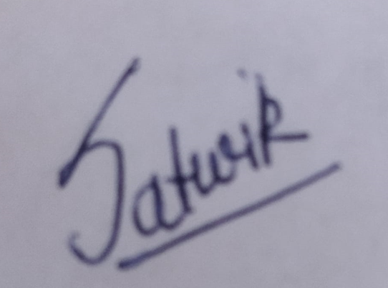 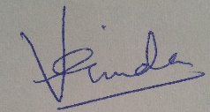 

**Dated: 09/01/2022** **Signature of students(s)**

**(Name(s)):**

**Satwik**

**Vrinda Kohli**

**Swapnil Gupta**

**Department:** **CSE**

## This is to certify that the above statement made by the candidates is correct to the best of my knowledge.

|  |  |
| --- | --- |
|  | Signature of Supervisor(Dr. Mala Saraswat)(Associate Professor)(Computer Science & Engineering Department) |

## 

## CERTIFICATE

This is to certify that Project Report entitled “Study Buddy” which is submitted by Satwik, Vrinda Kohli and Swapnil Gupta in partial fulfillment of the requirement for the award of degree B. Tech. in Department of Computer Science and Engineering of Dr. A.P.J. Abdul Kalam Technical University, formerly Uttar Pradesh Technical University is a record of the candidate own work carried out by him/them under my supervision. The matter embodied in this thesis is original and has not been submitted for the award of any other degree.

**Supervisor: Dr. Mala Saraswat**

**Date: 09/01/2022**

ACKNOWLEDGEMENT

*It gives us a great sense of pleasure to present the report of the B. Tech Project undertaken during B. Tech. Final Year. We owe special debt of gratitude to Professor Dr. Mala Saraswat, Department of Computer Science & Engineering, ABESEC Ghaziabad for her constant support and guidance throughout the course of our work. Her sincerity, thoroughness and perseverance have been a constant source of inspiration for us. It is only her cognizant efforts that our endeavors have seen light of the day.*

*We also take the opportunity to acknowledge the contribution of Professor (Dr.) Divya Mishra, Head, Department of Computer Science & Engineering, ABESEC Ghaziabad for her full support and assistance during the development of the project.*

*We also do not like to miss the opportunity to acknowledge the contribution of all faculty members of the department for their kind assistance and cooperation during the development of our project. Last but not the least, we acknowledge our friends for their contribution in the completion of the project.*

 

*(Signature) (Signature)*

*Name : Satwik Name : Vrinda Kohli*

*Roll No.: 1803210134 Roll No.: 1803210183*

*Date : 09/01/2022 Date : 09/01/2022*



*(Signature)*

*Name : Swapnil Gupta*

*Roll No.: 1803210156*

*Date : 09/01/2022*

ABSTRACT

*We are an all-in-one package for your studies. We provide automatically generated time table as well as pdfs and video links all for Free for our students of class 10th, 12th and those appearing for JEE.*

*Our aim**is to increase job opportunities for college students with expertise and retired teachers as well help school students divide their time and stay motivated.*

*We have noticed how kids are always stressed during exam days because they cant make a schedule to study. So we wanted to bring an end to those days of anxiety and fear.*

*We decided to make a website, “Study Buddy” where a student will have the following 4 options:*

1. *Generate Time table*
2. *Reference Material*
3. *Discussion Forum*
4. *Mentor Help*

*We wish to be a buddy for the students during their hard times. Our project will not only help the students, but will also provide an employment opportunity to retired teachers and college students.*

|  |
| --- |
|  |
|  |

**TABLE OF CONTENTS** Page

DECLARATION ii

CERTIFICATE iii

ACKNOWLEDGEMENTS iv

ABSTRACT v

LIST OF TABLES vi

LIST OF FIGURES viii

LIST OF ABBREVIATIONS xi

**CHAPTER 1 1**

1.1. Problem Introduction 1

1.1.1 Motivation 1

1.1.2. Project Objective 1

1.1.3. Scope of the Project 2

1.2 Related Pervious Work 2

1.3 Organization of Report 5

**CHAPTER 2 : SOFTWARE REQUIREMENT SPECIFICATION 6**

2.1. Product Perspective 6

2.1.1. System Interfaces 6

2.1.2. Interfaces 6

2.1.3. Hardware Interface 7

2.1.4. Software Interface 8

2.1.5. Memory Constraints 8

2.1.6. Operations 8

2.1.7. About Sockets 9

2.2. Product Functions 10

2.3 User Characteristics 10

2.4. Constraints 10

2.5 Assumptions and Dependencies 11

2.6. Apportioning and Requirements 11

2.7 Use Case 11

2.7.1 Use Case Model 11

**CHAPTER 3: SYSTEM DESIGN 13**

3.1 Architectural Diagram 13

3.2 Data Flow Diagram 14

3.3 ER Diagrams 17

**CHAPTER 4: IMPLEMENTATION AND RESULTS 18**

4.1. Software And Hardware Requirements 18

4.2. Assumptions and Dependencies  18

4.3. Implementation Details 18

4.3.1 Snapshot of Interfaces 19

4.3.2 Test Cases 29

4.3.3 Results 30

**CHAPTER 5: CONCLUSION 31**

5.1 Performance Evaluation 31

5.2 Future Directions 31

REFERENCES... .................................................................................................... 32

APPENDIX A ......................................................................................................... 34

# LIST OF TABLES

|  |  |  |  |
| --- | --- | --- | --- |
| **Table No.** | **Table Name** | **Page Number** |  |
| 1 | Analysis of different e-learning Platforms | 13 |  |

**LIST OF FIGURES**

**FIGURE 2.1**: Flow from Client To Server

**FIGURE 2.2**: Use of Emit and On emitters

**FIGURE 2.3**: Use Case Diagram

**FIGURE 3.1**: 3-Tier Architecture Diagram example

**FIGURE 3.2**: DFD Level 0

**FIGURE 3.3:** DFD Level 1

**FIGURE 3.4**: DFD Level 2

**FIGURE 3.5**: ER DIAGRAM

**FIGURE 4.1:** REST API’s

**FIGURE 4.2:** Student REST API’s

**FIGURE 4.3:** Subject REST API’s

**FIGURE 4.4:** Teacher REST API’s

**FIGURE 4.5:** Homepage Interface

**FIGURE 4.6:** About Us Interface

**FIGURE** **4.7:** Sign up page

**FIGURE** **4.8:** Pricing Interface

**FIGURE** **4.9:** Login Page

**FIGURE** **4.10:** After Logging in

**FIGURE** **4.11:** Contact Us Interface

**FIGURE** **4.12:** After Login Generate Time Table Interface

**FIGURE** **4.13:** Time Table Interface

**FIGURE** **4.14:** Faculty Help Interface

**FIGURE** **4.15:** Study Material Interface

**FIGURE** **4.16:** Discussion Forrum Interface

**FIGURE** **4.17:** Real Time Chat Application

**FIGURE** **4.18:** Responsive Application

**FIGURE** **4.19:** Features after login on responsive site

**FIGURE** **4.20:** Running Spring Boot Application

**FIGURE** **4.21:**Testing Inserting Data In Student Database Using Rest API

**FIGURE** **4.22:** Testing Successful message

**FIGURE** **4.23:** Data Successfully Entered In Student Database

**LIST OF ABBREVIATIONS**

|  |  |
| --- | --- |
| ER | Entity Relationship |
| DFD | Data Flow Diagram |
| TB | Tera Byte |
| GB | Giga Byte |
| REST | Representational State Transfer |
| IDE | Integrated Development Environment |
| SQL | Structured Query Language |
| HTML | Hypertext Markup Language |
| CSS | Cascading Stylesheet |
| SSD | Solid State drive |

**CHAPTER 1**

**INTRODUCTION**

* 1. **Problem Introduction**
     1. **Motivation**

Since we are students, we are aware of the pressure that a student faces.

We have been at a helpless place ourselves when we have to study weeks before out exams. Anxiety coupled with exam fear lowers our productivity.

The major motivation for our project is:

* Increasing competition in the world has increased the need for exams.
* Valuable time gets wasted while making a time table

This system has been developed to improve the and override the problems of the existing system. In all, this system is designed to provide easy access of learning and resources to students.

* + 1. **Project Objective**
* The objective of this project is to help students appearing for different exams by providing them proper resources and mentors under one platform so that they just have to focus on their preparation and nothing else.
* This project is to help retired teachers by providing them extra source of income by helping students for their queries and problem.
* Schools and Colleges can also use our curriculum to teach students which we our thinking as our future perspective.
  + 1. **Scope of the Project**
* The first one who could be benefitted from our project is the students. Once the major problem is identified, the students can take up the necessary actions accordingly.
* Enhance the nature of learning and instructing.
* The online programs could be engaged from household so there are very less chances of students missing out on lessons.
* Our project Study Buddy will help all students preparing for any exams whether normal or competitive of any field.
* The other broader and future perspective of this project will help teachers by providing them with a proper source of income.
* Study Buddy can also be accessed by schools and colleges as a source of their curriculum
  1. **Related Previous Work**

A lot of this work has already been done in this field.

* Websites like Udemy and Coursera are there which provide you with courses and certification but that is without effective time management learning .
* Websites like two waits, brainly provide with just study material and questions answers.
* Because of internet erudition, technology has become a part of daily lives. Whether it is using Google Meet or teams for online classes. But they come with distractions of other video streaming platforms.
* These platform Lack of learner engagement and motivation.
* There are also online time tables where you can make a to-do list for yourself. But no matter how many times you try to shift timings, it is difficult to make timelines of work in our favor.

A lot of this work has already been done in this field. Websites like Udemy and Coursera are there which provide you with courses and certification but that is without effective time management learning.

Udemy provides lifelong learning with a variety of educated experts to cater to their large number of students. It is a new approach to classroom learning but with technology integrated. Their marketplace model captures the student’s and the teacher’s intention of enrolling. It is a self-sustaining model of education that provides courses to students depending on their interest and also helps to provide a source of income for the instructors [4].

Websites like two waits, brainly provide with just study material and questions answers. Because of internet erudition, technology has become a part of daily lives. Whether it is using Google Meet or teams for online classes. But they come with distractions of other video streaming platforms. These platforms Lack learner engagement and motivation.

MOOCS or the “Massive Open Online Courses” are also at a remarkable rise. Coursera and the edX are the two MOOC’s provider. They have a strong business model as they provide both free and paid courses for the students. Students can pay for the course they want to enroll in and also get a certificate of completion upon successfully completing the course.[7]

It is also debated whether MOOC’S are beneficial and if it is worth paying for the certificate? Since it contains some famous online degree programs of various universities, some students left their internships to do MOOC’s courses [9]. For automatic time table generation there have been many algorithms that are being used to reduce the time and manual work by the student. Evolutionary Algorithm and manually generated time tables are of a kind. The former is used with Heuristic and context-based reasoning method and the latter provides more of a manual work which changes depending on student’s choices. Heuristic approach is a general approach for generating the time table [3].

The idea that we are implementing is unique. We haven’t found any website that would provide a timetable for the student depending on the priority of his subjects and the deadline of the exam. It provides students with the guidance/support they need. The software we build covers all of the requirements needed by students during exam days.

**Table 1:** Analysis of different e-learning Platforms

|  |  |  |  |  |  |  |  |
| --- | --- | --- | --- | --- | --- | --- | --- |
|  | PDF | VIDEO LECTURE | LIVE CLASSES | DISCUSSION FORUM | TIMETABLE GENERATION | PROVIDING EMPLOYMENT | CERTIFICATE PROVIDED |
| UDEMY | **☒** | **☑** | **☒** | **☑** | **☒** | **☑** | **☑** |
| COURSERA | **☒** | **☑** | **☒** | **☑** | **☒** | **☒** | **☑** |
| TWOWAITS | **☑** | **☒** | **☒** | **☑** | **☒** | **☒** | **☒** |
| SITES HAVING TIME TABLE GENERATION | **☒** | **☒** | **☒** | **☒** | **☑** | **☒** | **☒** |
| **STUDY BUDDY** | **☑** | **☑** | **☑** | **☑** | **☑** | **☑** | **☒** |

The above table shows the analysis and comparison of 3 already existing e-learning websites with our software research work idea. All the websites separately cover the points, but our website brings all these points under a single roof.

While Udemy and Coursera provide with video lectures for different subjects and courses respectively, Two Waits provides with only the PDF’s. Study Buddy on the other hand contains both PDF and video lectures. Discussion forum is common amongst most of the sites.

Another thing that sets us apart is “time table generation”. The only thing lacking in Study Buddy is providing certificate of completion.

* 1. **Organization of the Report.**
* The first chapter of report, demonstrated the problem statement of our project which is analysis and density estimation and also provides an insight of objective and scope of the project. The details of related previous work carried in the field of project, research work and summary of the results obtained has been given in the chapter.
* Our second chapter is about software Requirement Specification.

A Specification of Software Specifications (SRS) is an archive that portrays a project, or application concept. SRS Record is a project manual in plain words, provided it is set up before you start a task/application.

Software Interfaces:

1. **Spring Boot (JAVA):** It has been used to write down the backend logic.
2. **React v9.0.0**: It is used as a front hand technology. It gives our project more robust features.
3. **MySQL:** It is used to save or create and update the data we are using for our analysis. It keeps a record of full data of students who pass out and keep track of their skills they are working on.

* The third chapter has provided a software requirement specification of the project. Here we have presented our DFD’s and ER Diagrams along with the software used in the project.
* Our fourth chapter contains all the snapshots from the project and results.
* Our fifth chapter contains the conclusion. It contains all the performance evaluation measures and future directions which can be implemented in order to make the project more successful.

**CHAPTER 2**

# SOFTWARE REQUIREMENT SPECIFICATION

**2.1 Product Perspective**

The idea which we are implementing is a unique idea. We haven’t found any website that would provide a time table for the student depending on the priority of his subjects and the deadline of the exam. It provides students the guidance/support they need. The software we build covers all of the requirements needed by student during exam days.

### 

### 2.1.1 System Interface

* HTML5, JavaScript, CSS3 and Bootstrap have been used for making the frontend of the application.
* Spring Boot In Java is used to write the codes for the backend.
* React Js is used to write the code for the front end as well. It made our web page more dynamic.
* MySQL is used to store and modify data. It is the base of the software.
* Swagger and Postman for hitting the API and checking the response.
* Socket.IO used for discussion forrum

### 2.1.2 Interfaces

We used many interfaces like:

* **Login/Signup:** This​ interface lets users’ login the application and avail services that our website provides.
* **Logout:** This page would redirect users to the login page.
* **Home Interface:** This page allows users to see users to see posts which are posted by other users.
* **Generate Time-Table:** this page will ask the student to enter the deadline for his exam along with the priorities of his understanding a subject and then time table will be generated.
* **Pricing:** This page has the pricing scheme for if the student plans to have a one-on-one interaction with the teacher.
* **Faculty Interface:** This screen allows all users to see the available teachers along with their designations and subject expertise.
* **Discussion Interface:** This screen allows users to direct message other users as a means of communication Interface.This is done using sockets

### 2.1.3 Hardware Interfaces

* Processor: Intel i3-4200U / Intel Core or better​.
* GPU: 1.30Ghz
* Ram: 2GB or more.
* Hard Disk: 20GB or more.
* Operating System: Windows.
* Input Device: Standard Keyboard, Mouse and USB.
* A browser which supports HTML and JavaScript.
* Internet Connection.

### 2.1.4 Software Interfaces

* **React JS v9.0.0:** It is used ​ as a front hand technology. It gives our project more robust features.
* **Microsoft SQL server v8.0​:** It is used to save or create and update the data we are using for our analysis. It keeps a record of full data of students and faculty who log in.
* **Spring Boot v2.6.2**: It is been used to write down the backend logic i.e., Chain code for the automation of the transactions. We have used Java 11 for writing the backend code.
* **Postman V9 and Swagger UI V 2.2.1:** to check the rest API functioning.

### 

### 2.1.5 Memory Constraints

* Primary Memory: 2GB or above.
* Secondary Memory: 20GB or above.

### 2.1.6 Operations

Operations required by the users:

* Profile Creation
* Give priorities of understanding of the subject to generate time table
* Discussion forum
* Explore different teachers
* Pay if availed any service
* Download the study notes

### 2.1.7 About Sockets

Socket.IO is a library that enables **low-latency**, **bidirectional** and **event- based** communication between a client and a server.

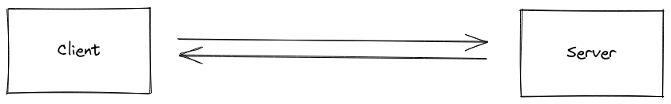

Figure 2.1:Flow from Client to Server

Sockets is a powerful tool for making real time chat applications as it creates a room for sending message to individual and broadcasting messages to a group joined under a similar link or room.

We can use commands or EventEmitter like

**-** Emit **-** On **-** Off **-** Once

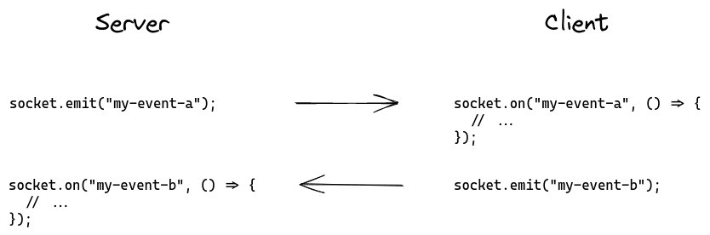

Figure 2.2: Use of Emit and On emitters

## 2.2 Product Functions

* It allows user to register themselves on the site i.e., log in/out, signup.
* Users can see their profiles in the profile section.
* Users can then navigate to either generate time table section, discussion forum, online class page or study material.
* In generate the time table page, the most suitable time table will be provided to the user depending on the data entered by him.
* In discussion forum, the students can interact with each share notes or review about the teacher .
* In online class, they can decide the teacher and the payment plan and pay for the class accordingly.
* Finally, the student can also download pdf notes or videos.

## 2.3 User Characteristics

* Mainly students can register. And teachers can provide services to the students.
* Basic technical knowledge of using the computer system is required.
* Very user friendly and anyone with basic knowledge can operate easily.

## 2.4 Constraints

* The system shall be built using a standard windows operating system.
* There are some basic memory requirements to be fulfilled for using the software.
* Basic computational power is required for running the software.
* The computers must be equipped with web browsers such as Google Chrome.
* Response time for loading the site depends on your connection.
* A general knowledge of basic computer skills is required to use the website.

## 2.5 Assumptions and Dependencies

* It is expected that each user of our device will have a Windows operating system which will meet the above-mentioned software and hardware specifications.
* Developers have access to the technical resources needed for system creation.
* The criteria gathered are right and realistic.

## Apportioning of Requirements.

## We may not satisfy all the criteria at the moment; however, we plan to extend our project.

## We intend to make a separate mobile application which would be easily accessible for all students and teachers that can be managed by all as well.

## We also intend to add certain features like extending it to all classes and then even to the college curriculums.

## We also would like to include other competitive exams like GATE, CAT, etc. preparation also.

* 1. **Use case**

# Use case Model

Users can see the basic screen and faculty will have their own interface to log into.

Here, a relationship between the user and the different functionalities is shown.

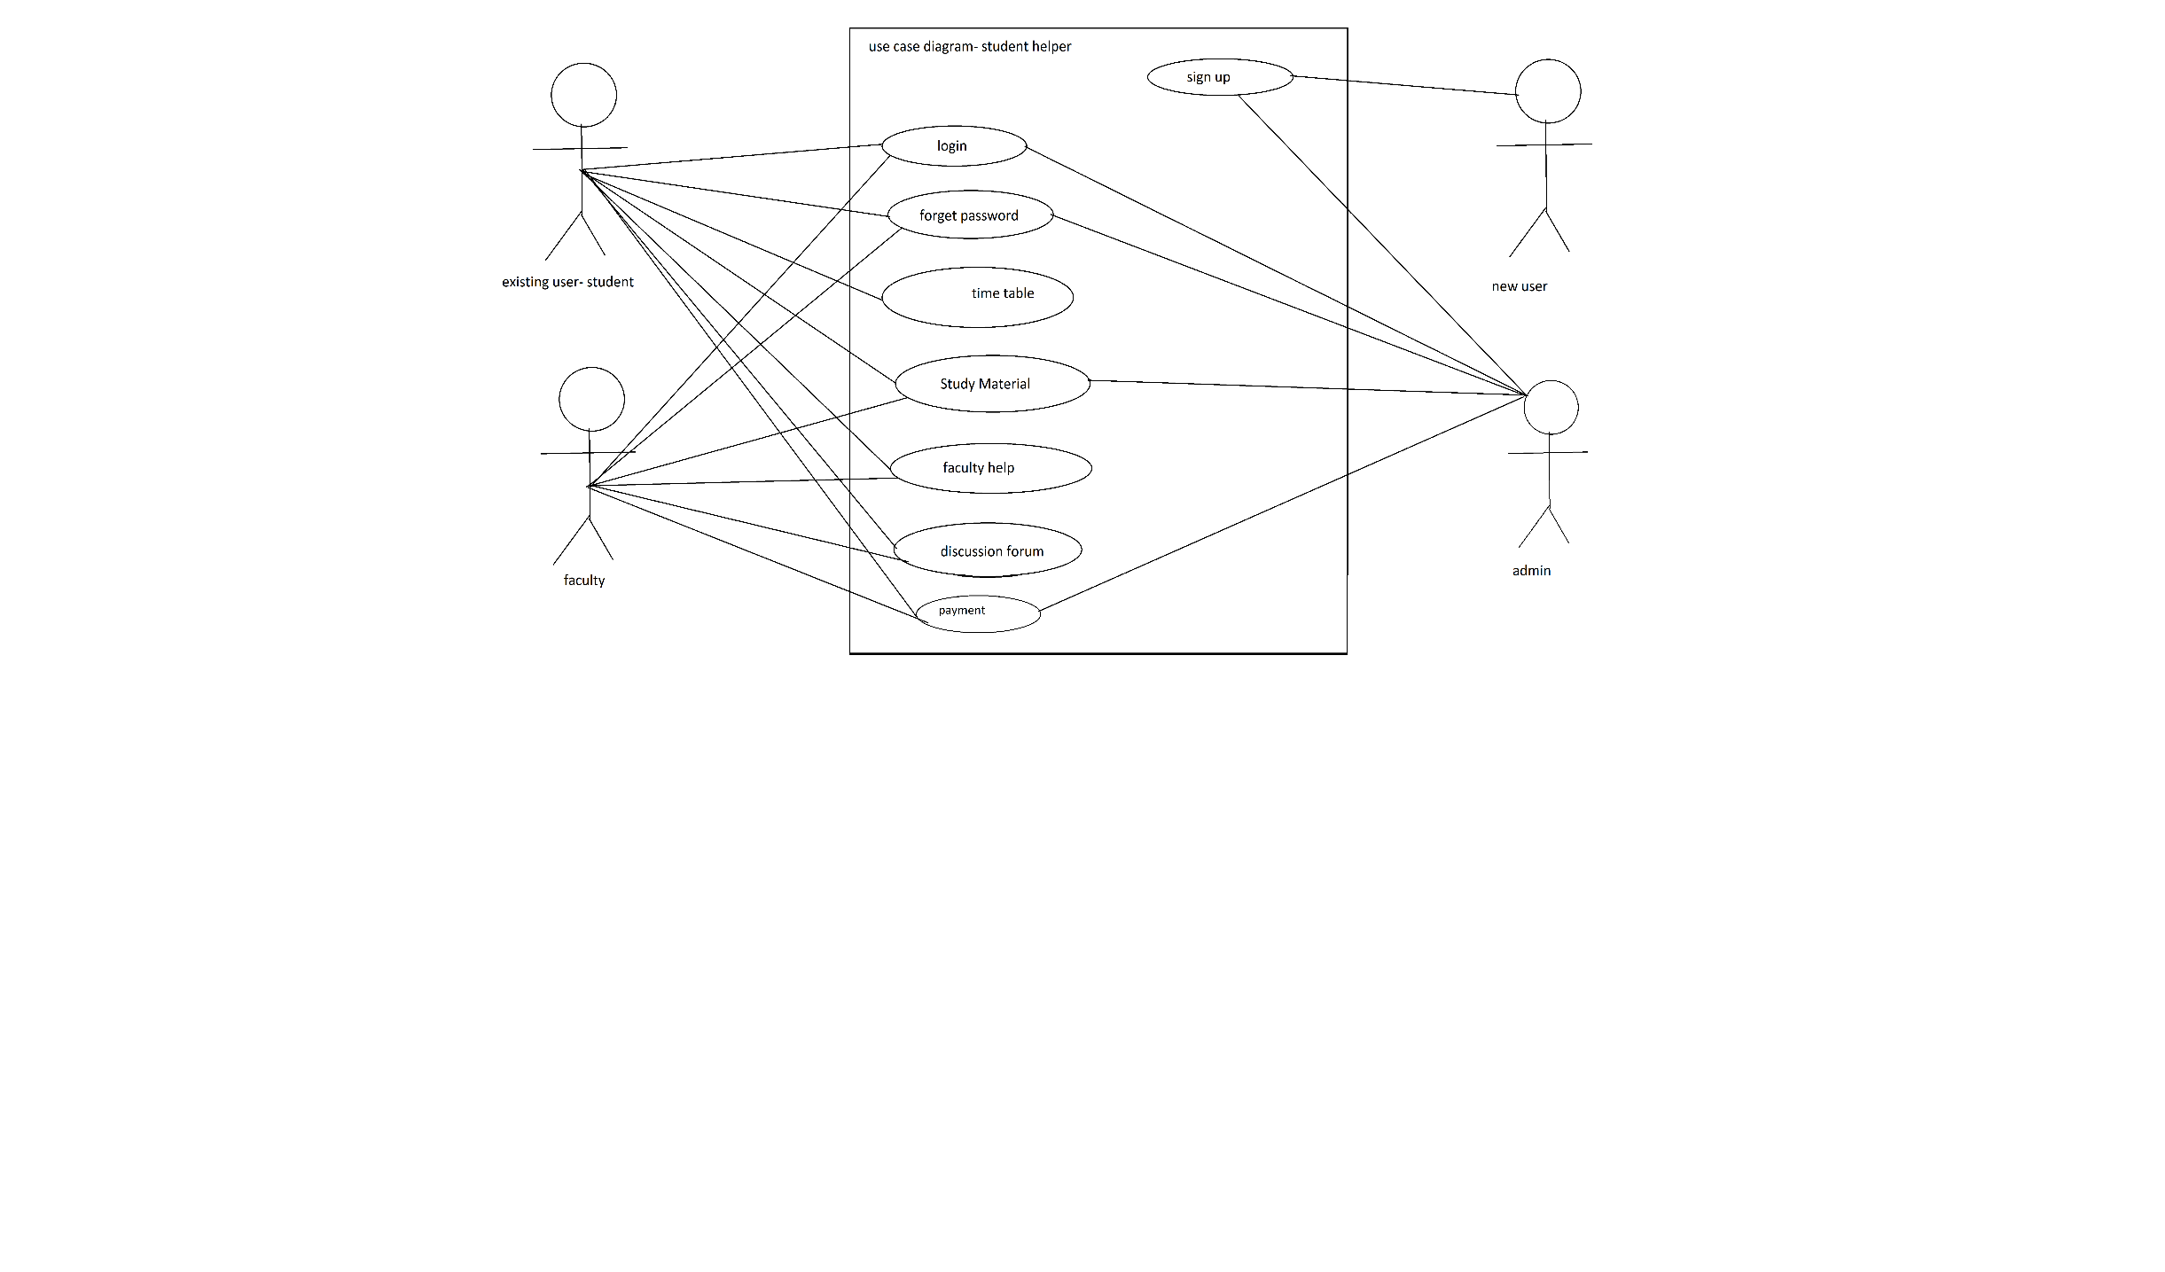

Figure 2.3: Use Case Diagram

# CHAPTER 3

# SYSTEM DESIGN

# Architecture diagrams

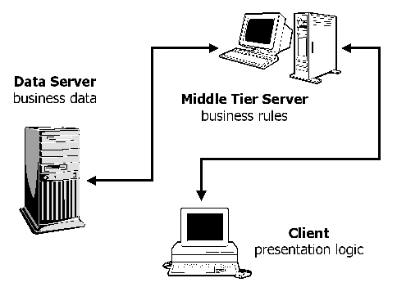

Figure 3.1 3-Tier Architecture Diagram example

* 1. **Data Flow Diagram**

**DFD LEVEL-0**

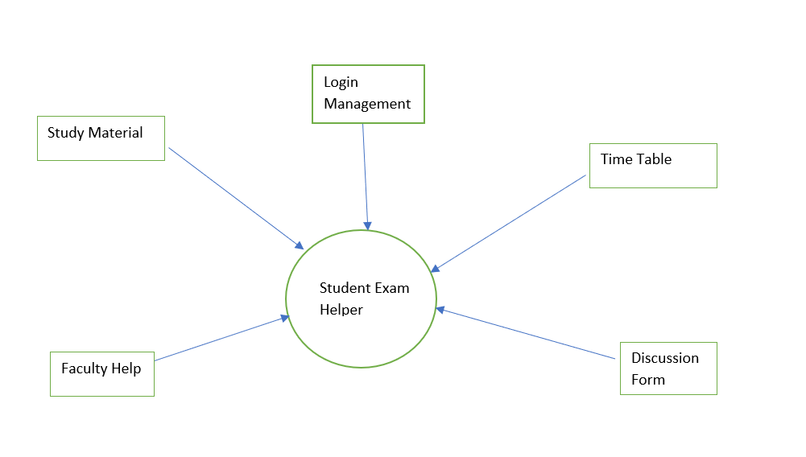

Figure 3.2 DFD Level 0

**DFD LEVEL-1**

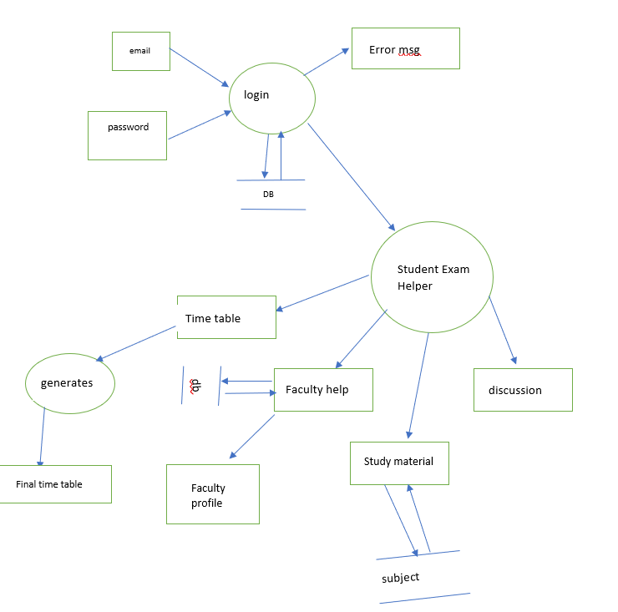

Figure 3.3 DFD Level 1

**DFD LEVEL-2**

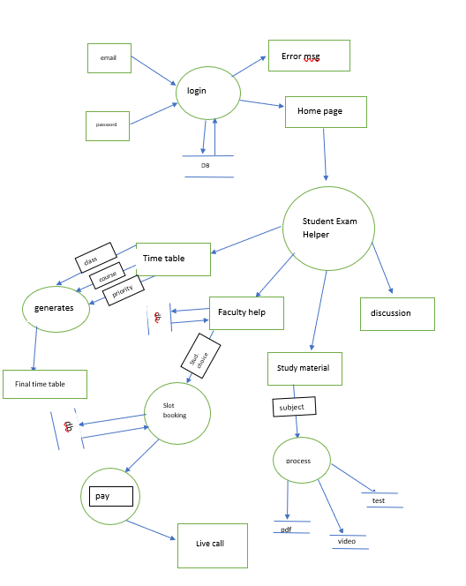

Figure 3.4 DFD Level 2

# ER Diagrams

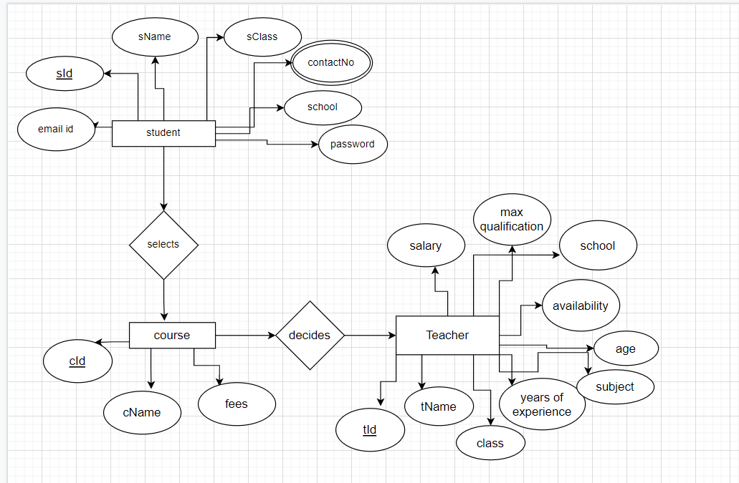

Figure 3.5 ER DIAGRAM

**CHAPTER 4**

# IMPLEMENTATION AND RESULTS

* 1. **Software and Hardware Requirements**

Various software’s are required for the development of this project. Some of the software’s are -

* Google Chrome
* Good internet connectivity

Hardware requirements are-

* Core i3 8th generation
* RAM 8gb (minimum)

* 1. **Assumptions and dependencies**

We have assumed that people will have access to good connection and are well versed on how to use a computer.

* 1. **Implementation Details**
     1. **Snapshots Of Interfaces**

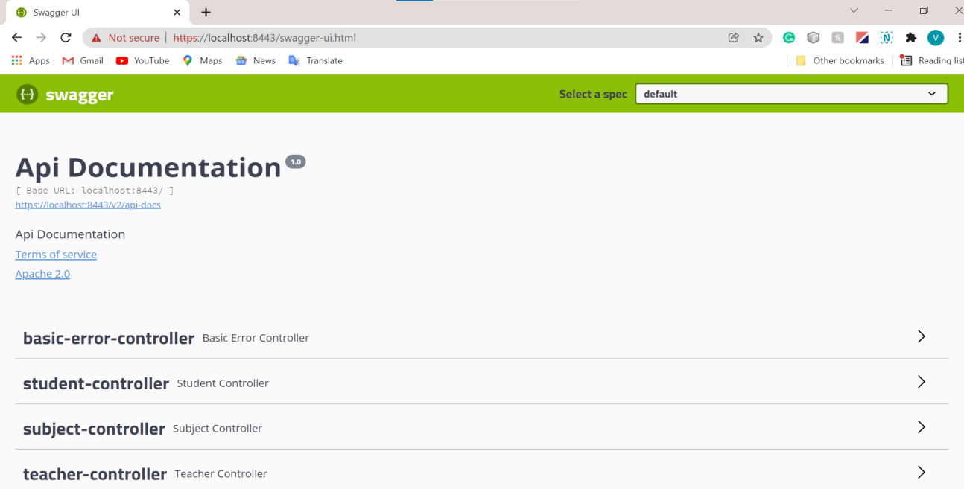

Figure 4.1 REST API’s

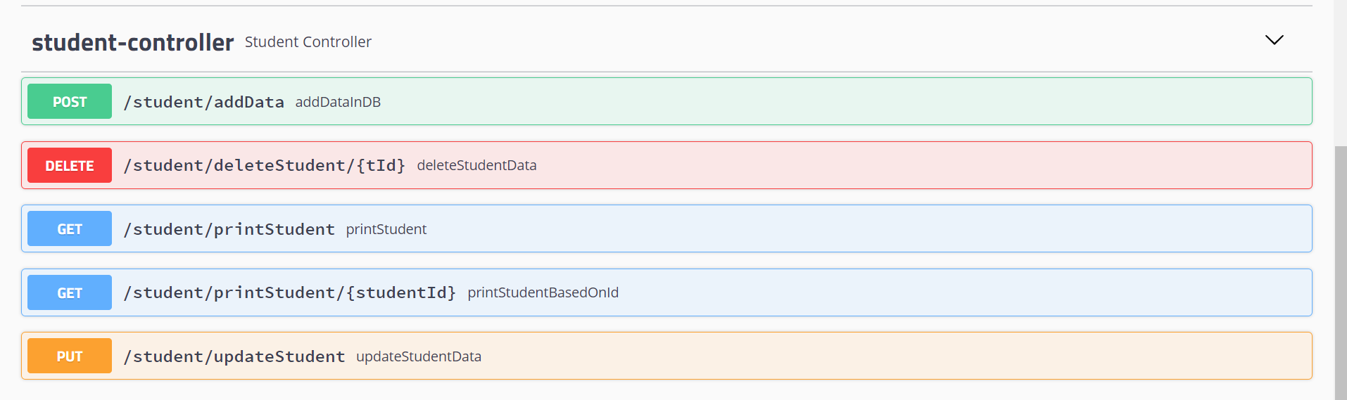

Figure 4.2 Student REST API’s

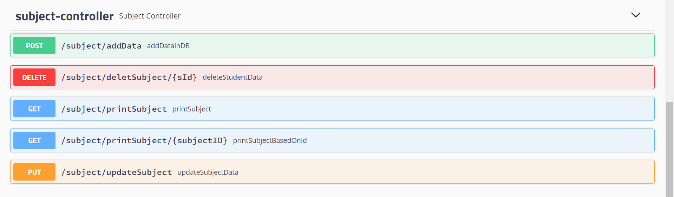

Figure 4.3 Subject REST API’s

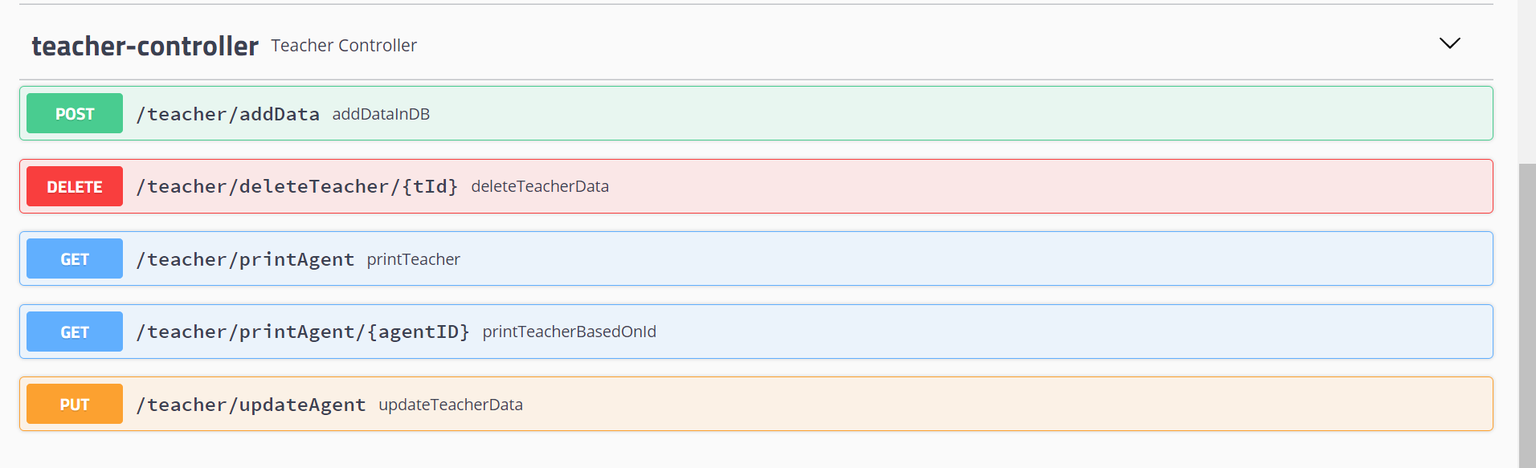

Figure 4.4 Teacher REST API’s

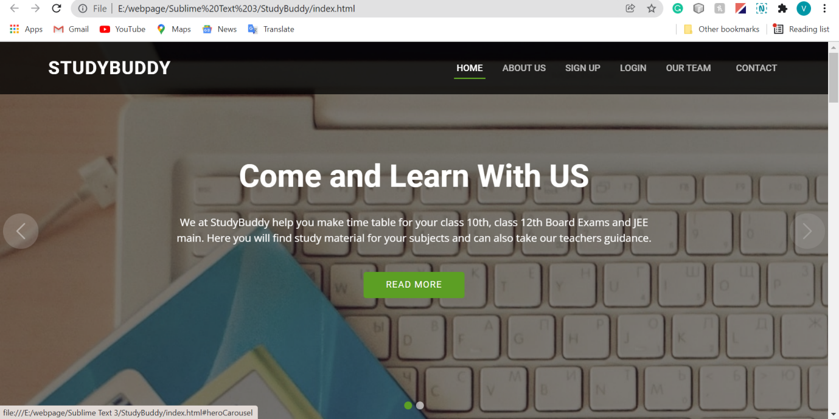

Figure 4.5 Homepage Interface

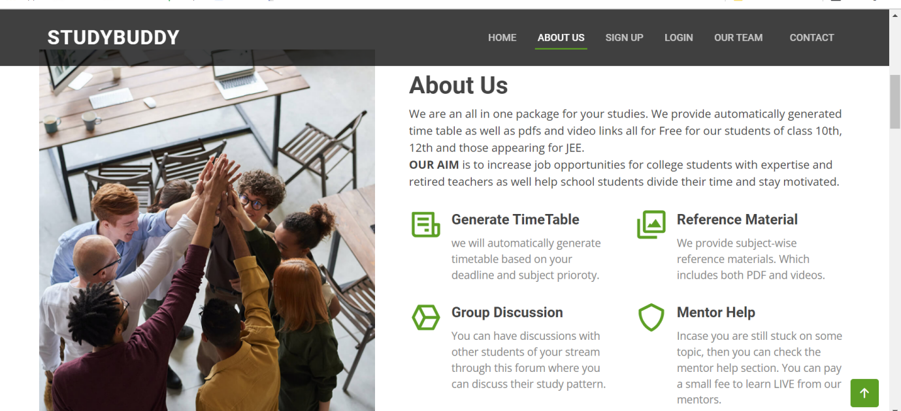

Figure 4.6 About Us Interface

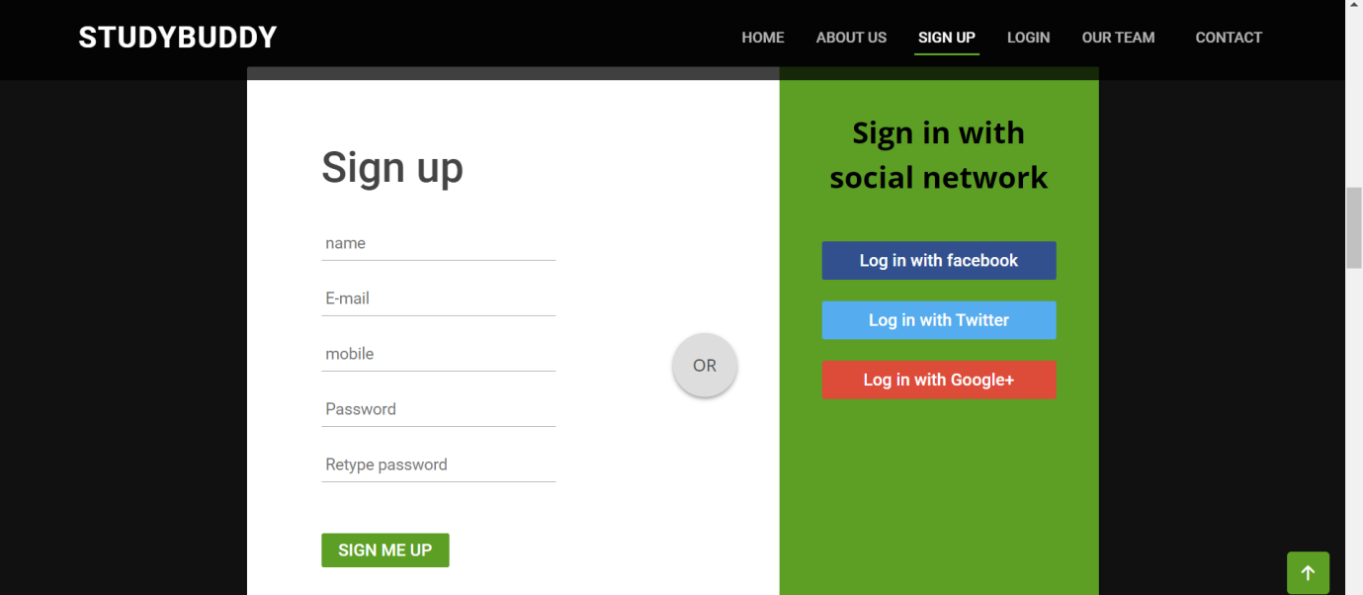

Figure 4.7 Sign up page

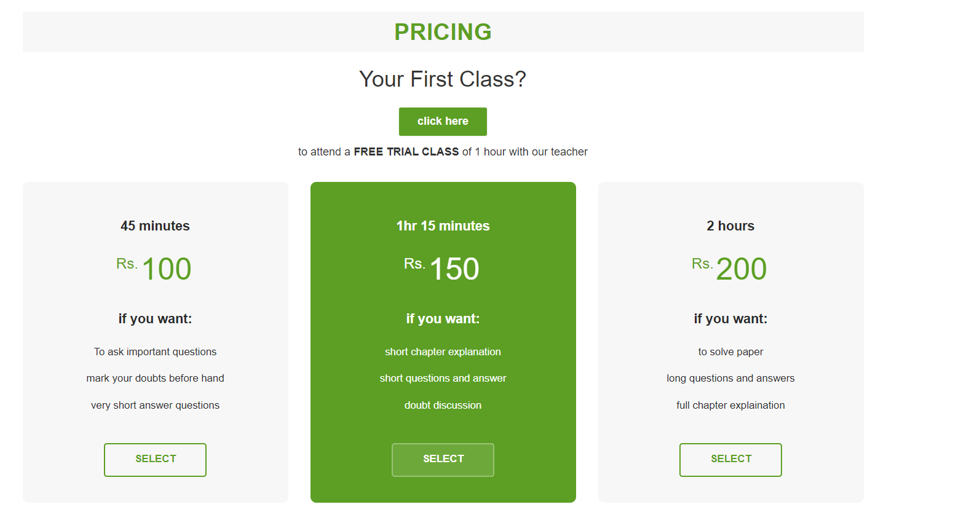

Figure 4.8 Pricing Interface

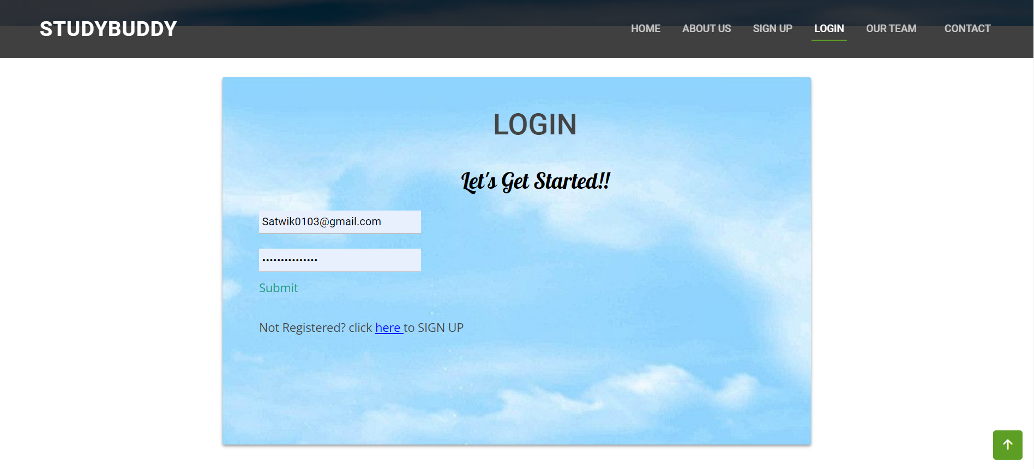

Figure 4.9 Login Page

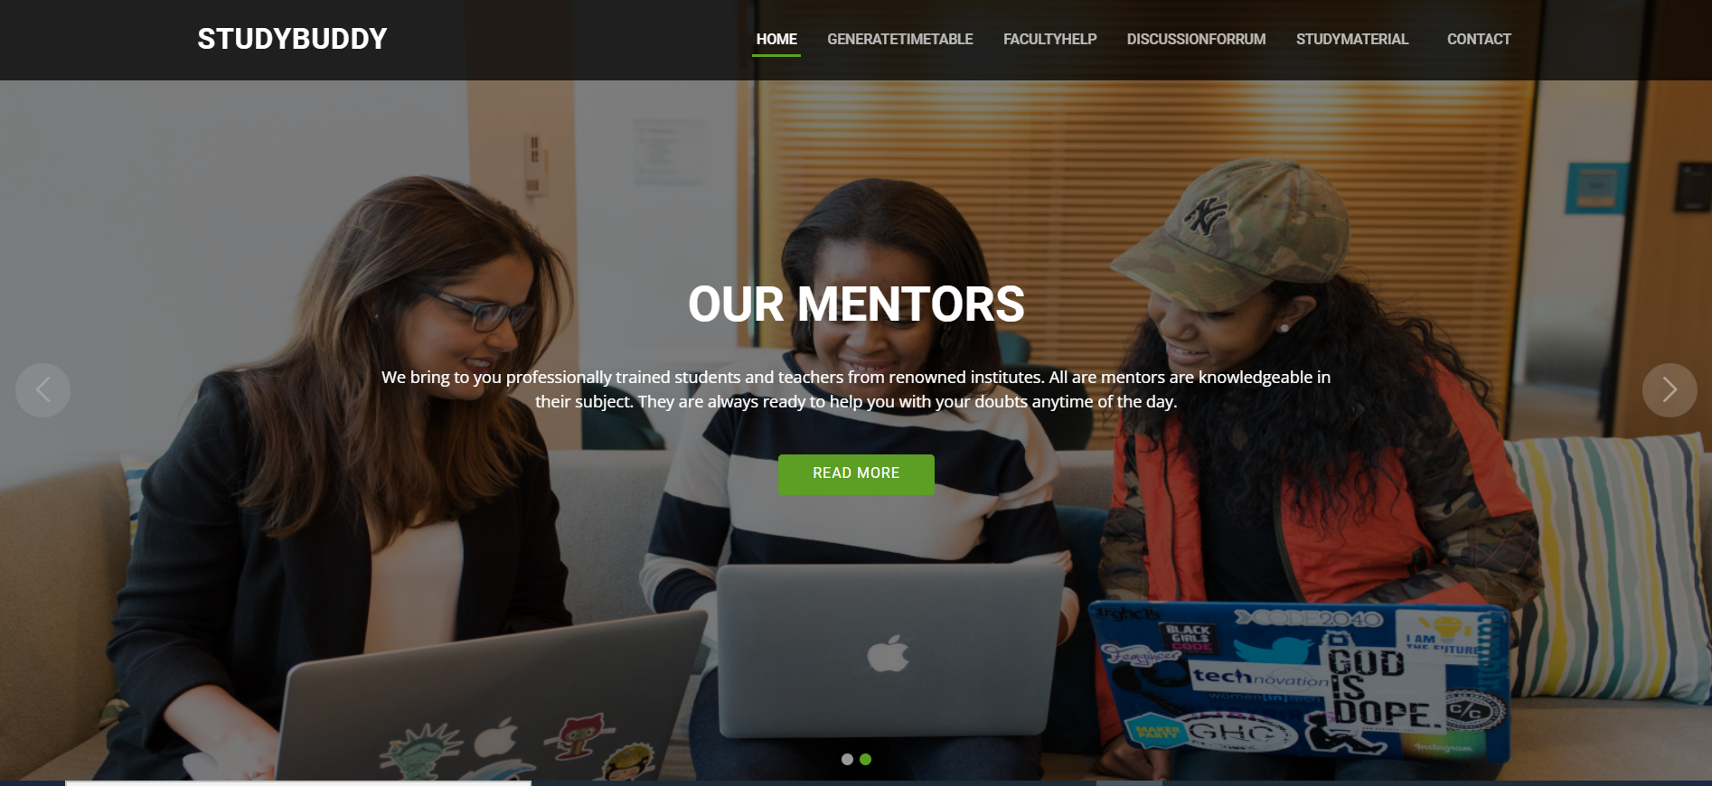

Figure 4.10 After Loging In

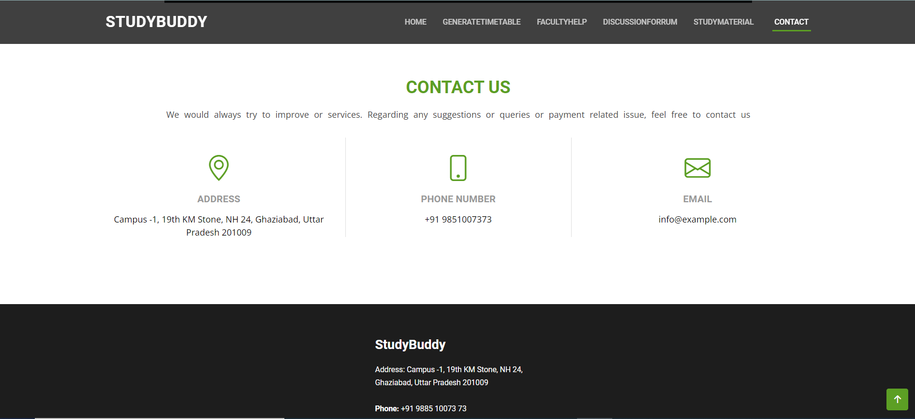

Figure 4.11 Contact Us Interface

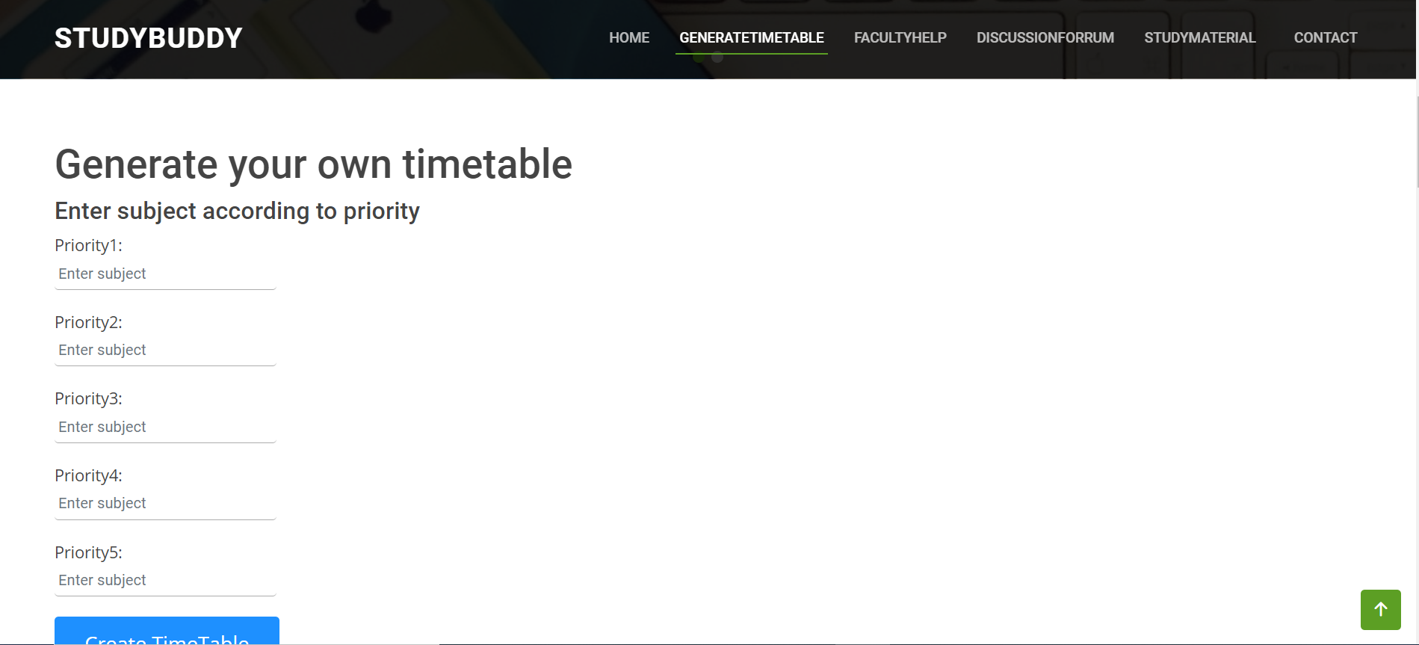

Figure 4.12 After Login Generate Time Table Interface

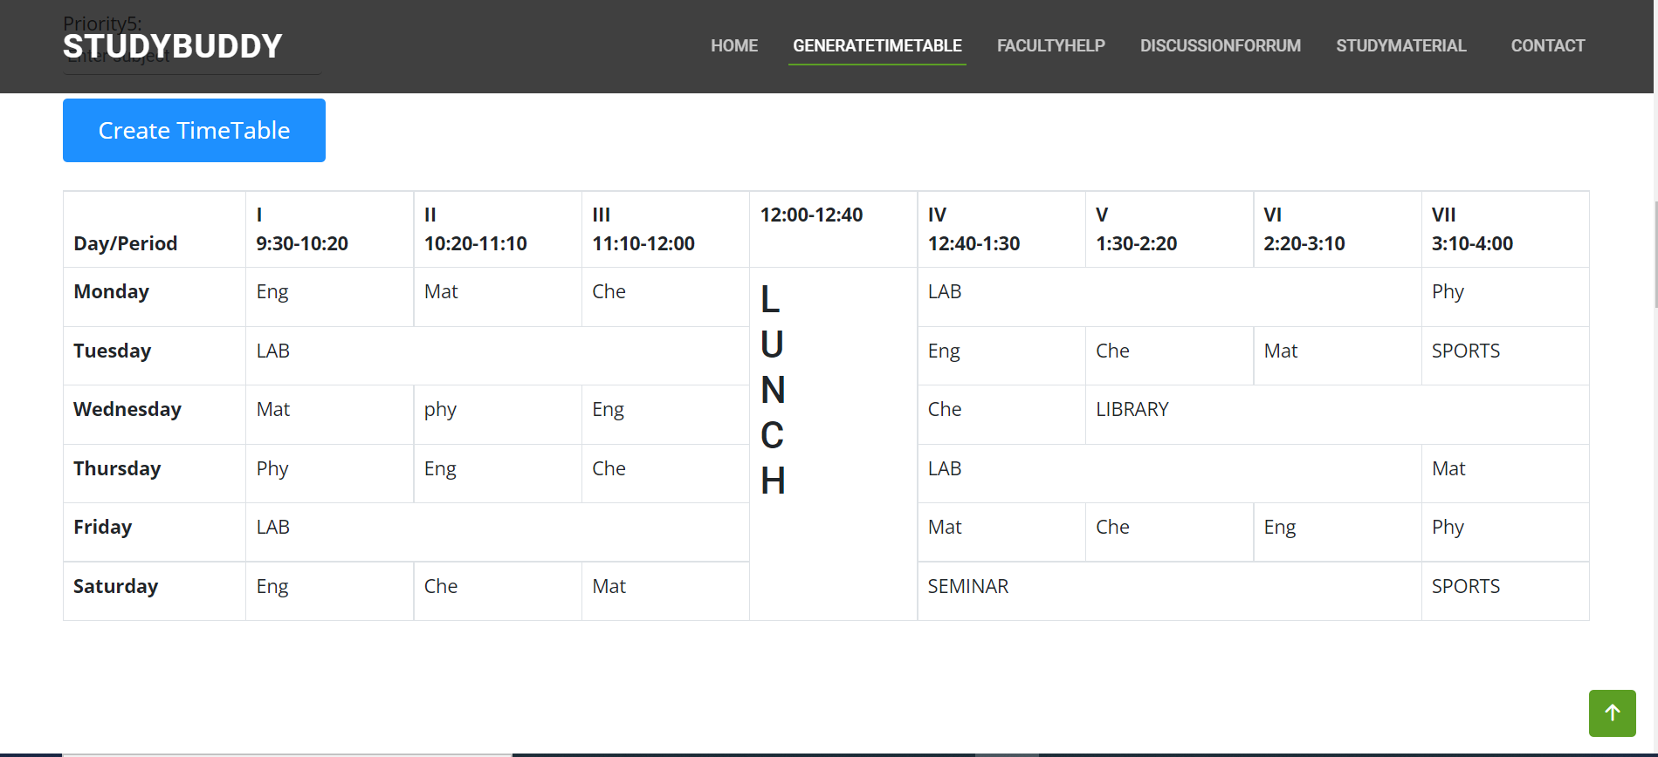

Figure 4.13 Time Table Interface

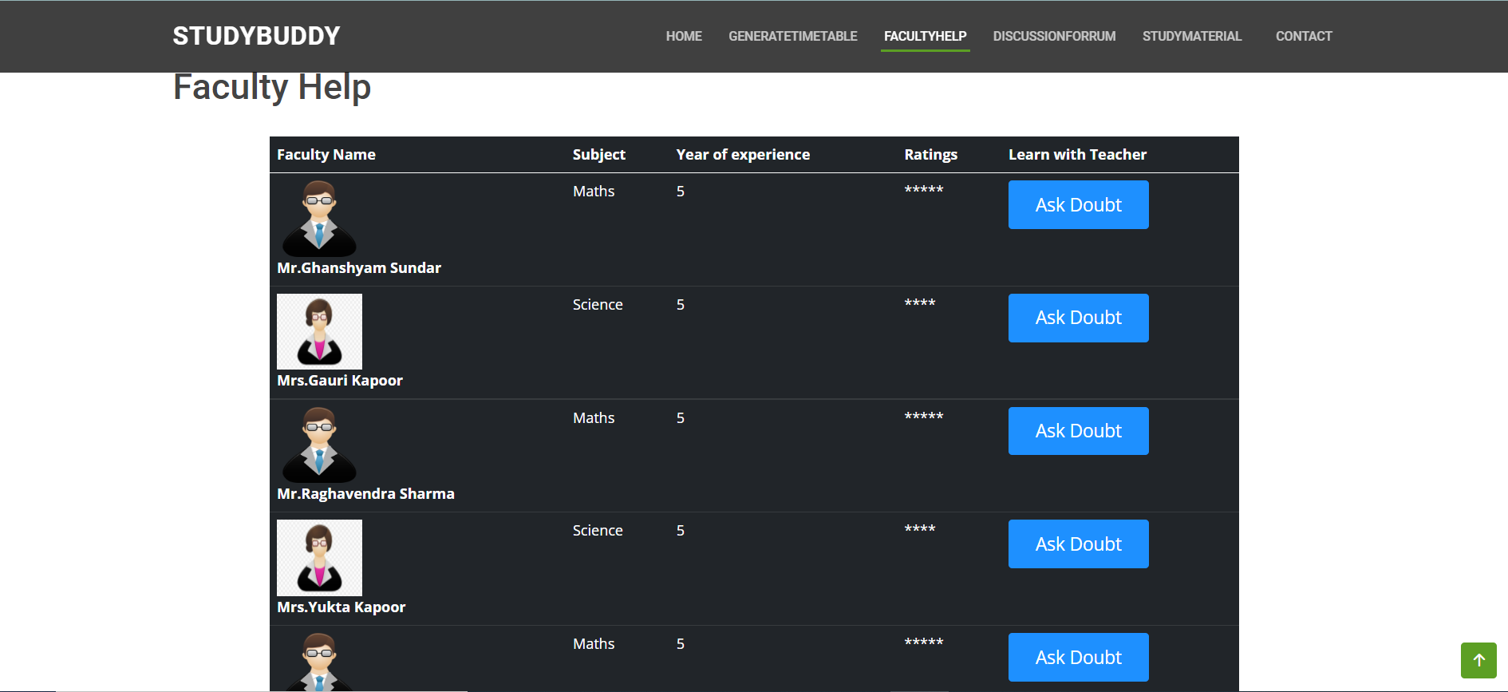

Figure 4.14 Faculty Help Interface

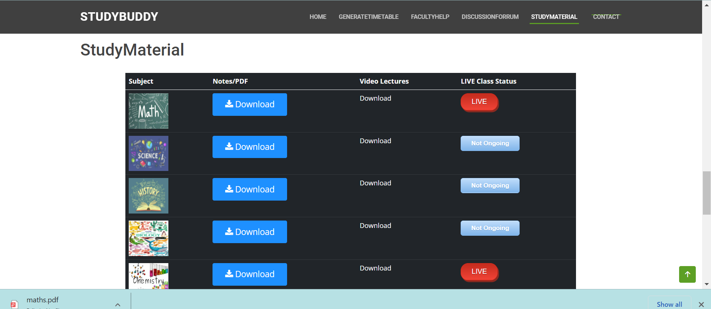

Figure 4.15 Study Material Interface

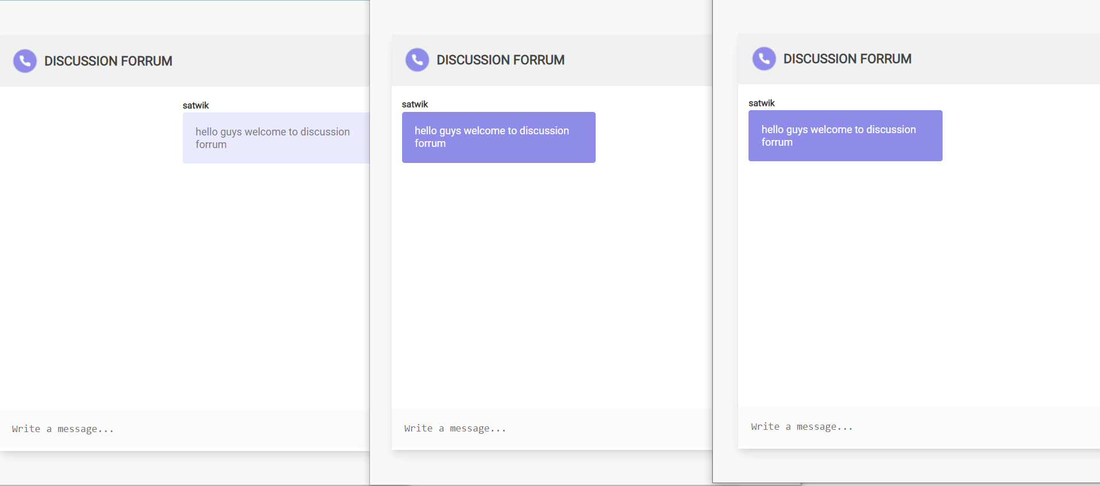

Figure 4.16 Discussion Forrum Interface

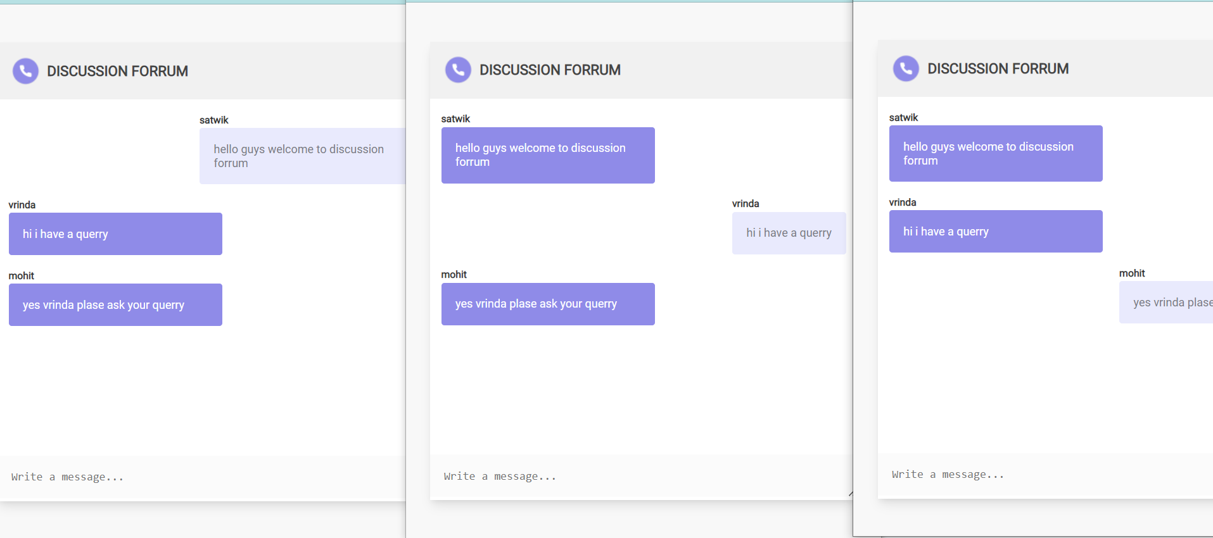

Figure 4.17 Real Time Chat Application

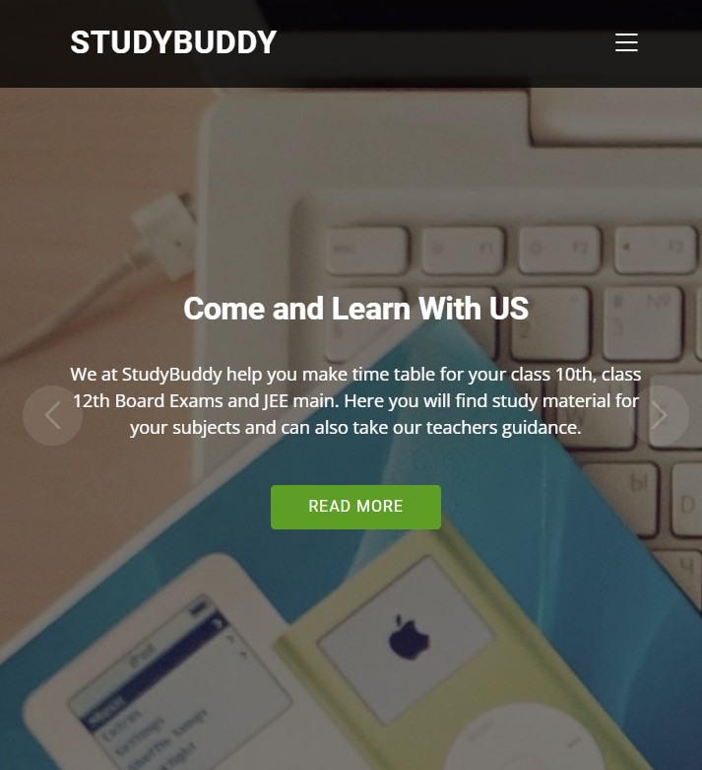

Figure 4.18 Responsive Application

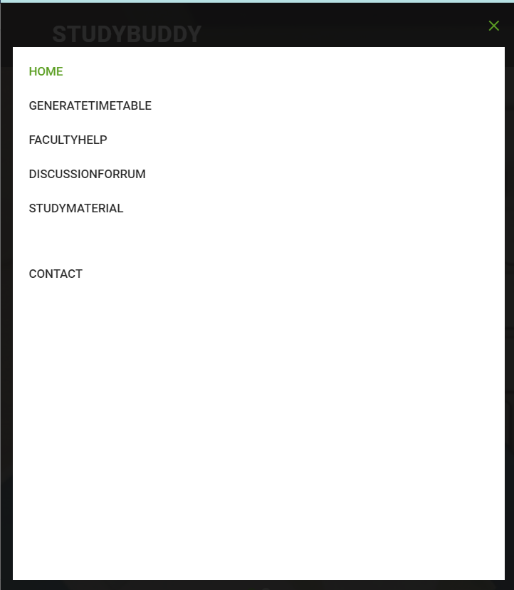

Figure 4.19 Features after login on responsive site

* + 1. **Test Cases**

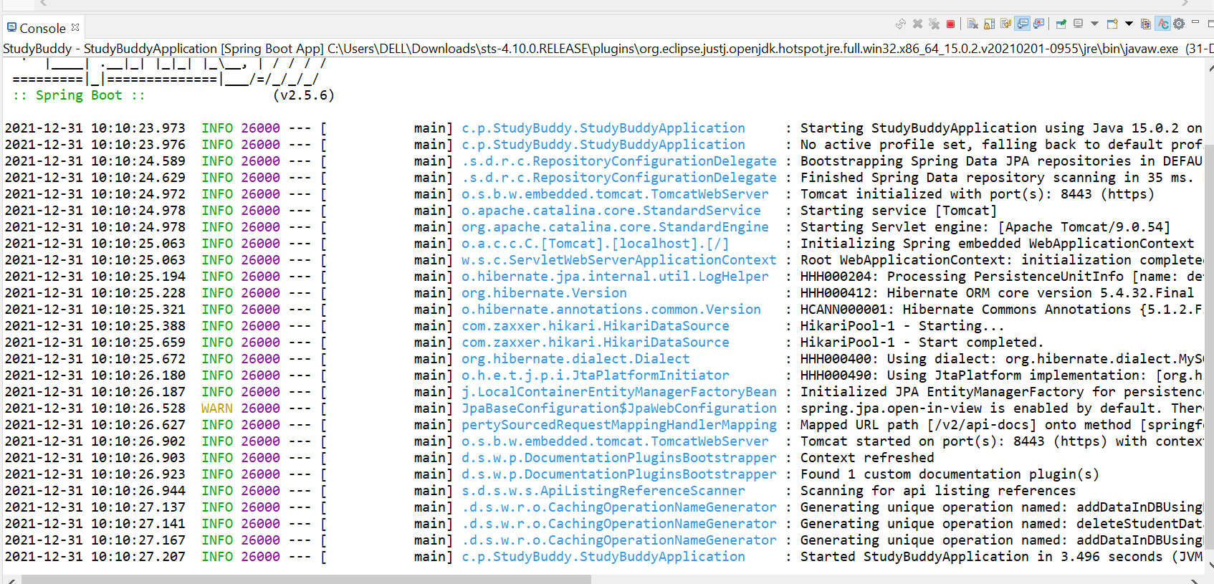

Figure 4.20 Running Spring Boot Application

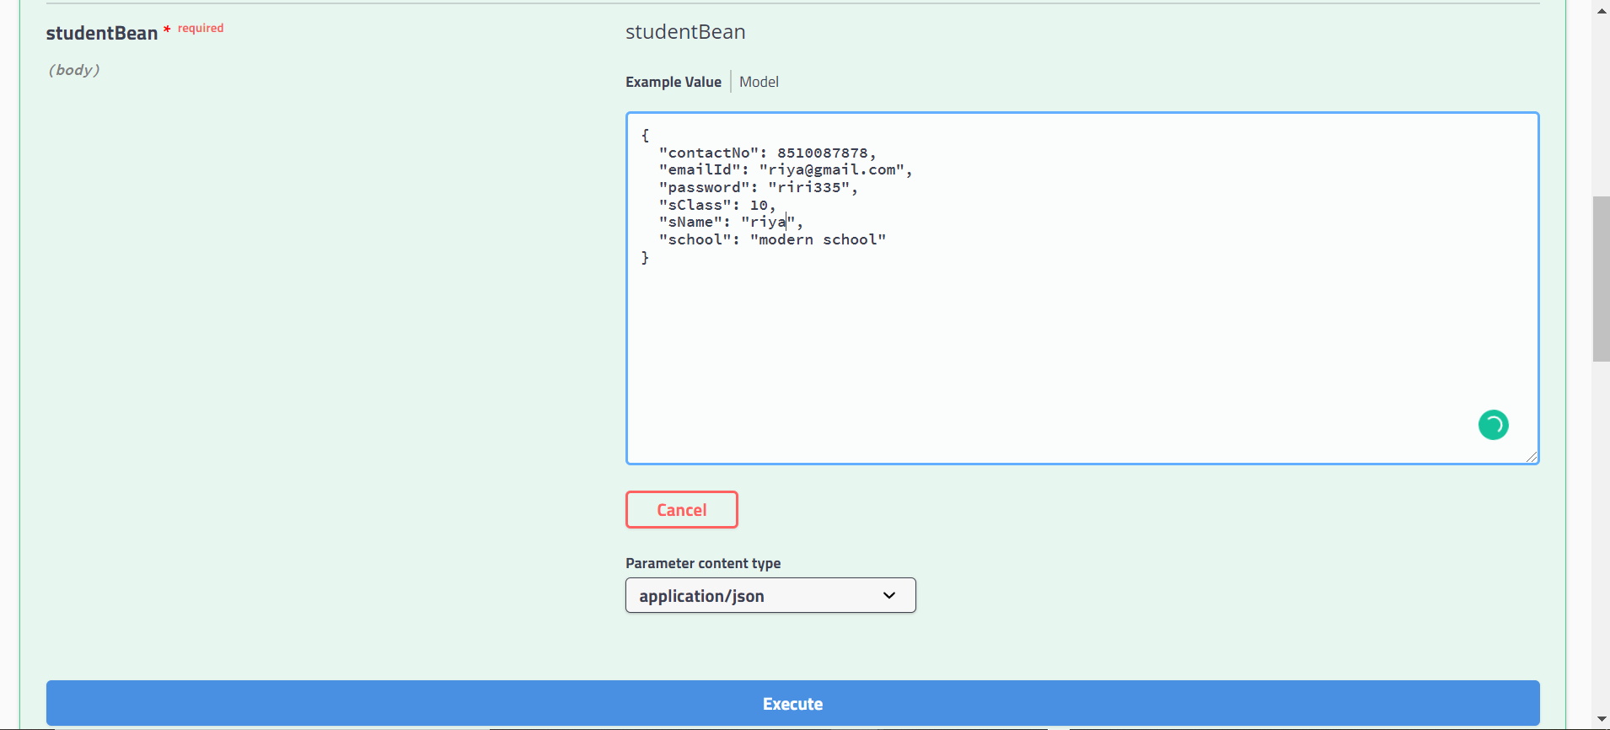

Figure 4.21 Testing Inserting Data In Student Database Using Rest API

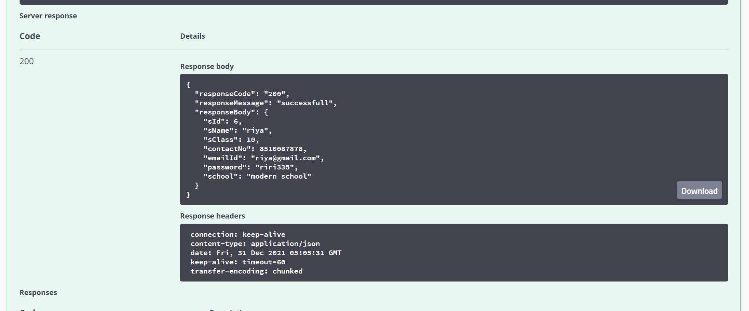

Figure 4.22 Testing Successful message

* + 1. **Results**

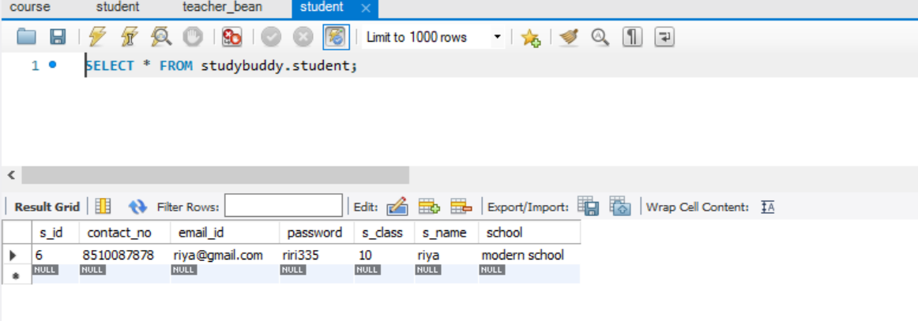

Figure 4.23 Data Successfully Entered In Student Database

**CHAPTER 5**

# CONCLUSION

* 1. **Performance Evaluation**

From the results, we can see that when inserting the data from the REST API, our data is visible in the database. This holds true for all the tables.

We have used the GET, POST, PUT and DELETE methods and all are working fine.

* 1. **Future Directions**

We are further planning to incorporate data analysis and machine learning to study the majority and the type of students using our website

We want to expand our website and time table generation capability to not only the BOARD classes but also to all the classes as well for competitive exams like GMAT, GRE, etc.

**REFERENCES**

Thumb rules followed to refer some one’s work are given below.

1. Allen, I. E., & Seaman, J. (2008). *Staying the course: Online education in the United States, 2008*. Sloan Consortium. PO Box 1238, Newburyport, MA 01950.
2. Sharma, P. (2005). Distance education and online technologies in India. *Global Perspectives on E-learning: Rhetoric and reality*, 52-66.
3. Aditya, K. S., & Jha, Girish. K. (2020). Students’ Perception and Preference for Online Education in India During COVID-19 Pandemic.
4. Cetina, I., Goldbach, D., & Manea, N. (2018). Udemy: a case study in online education and training. *Revista Economică*, *70*(3).
5. Jena, P.K., 2020. Online learning during lockdown period for covid-19 in India.

International Journal of Multidisciplinary Educational Research (IJMER), 9.

6.Ambhore, S., Walke, P., Ghundgrudkar, R., Alone, A. and Khedkar, A.,

Automatic Timetable Generator.

7. Abhinaya, V., Sahithi, K. and Akaanksha, K., 2019. Online Application of

Automatic

Time-Table Generator. *International Research Journal of Engineering and*

*Technology (IRJET)*, *6*(02).

8. Qiu, R., 2020. Udemy: Blended and e-Learning for Transforming Teaching and

Learning. In Anticipating and Preparing for Emerging Skills and Jobs (pp. 215-

1. . Springer, Singapore.

9. Muthuprasad, T., Aiswarya, S., Aditya, K.S. and Jha, G.K., 2021. Students’

perception and preference for online education in India during COVID-19

pandemic. Social Sciences & Humanities Open, 3(1), p.100101.

10. Hnatkowska, B. and Cebinka, M., 2021. Activity Diagram Generation Based on

Use-Case Textual Specification. Computing and Informatics, 40(4), pp.772-795.

11. Mamgain, N., Sharma, A. and Goyal, P., 2014, December. Learner's perspective

on video-viewing features offered by MOOC providers: Coursera and edX. In 2014

IEEE International Conference on MOOC, Innovation and Technology in

Education (MITE) (pp. 331-336). IEEE.

12. Henriyan, D., Subiyanti, D.P., Fauzian, R., Anggraini, D., Aziz, M.V.G. and

Prihatmanto, A.S., 2016, October. Design and implementation of web based real time chat interfacing server. In 2016 6th International Conference on System

Engineering and Technology (ICSET) (pp. 83-87). IEEE.

13. Despujol, I., Castañeda, L. and Turró, C., 2022. What Does the Data Say about

Effective University Online Internships? The Universitat Politècnica de València

Experience Using MOOC during COVID-19 Lockdown. Sustainability, 14(1),

p.520.

14. Luan, X., 2021. IMPLEMENTATION AND ANALYSIS OF SOFTWARE

DEVELOPMENT IN SPRING BOOT (Doctoral dissertation, California State

Polytechnic University, Pomona).

15. Zhang, J., Hu, H. and Huo, S., 2021. A Browser-based Cross Site Request

Forgery

Detection Model. In Journal of Physics: Conference Series (Vol. 1738, No. 1, p.

012073).

IOP Publishing

## ANNEXURE

1. **Additional Readings**
   1. <https://socket.io/docs/v4/>
   2. <https://www.redhat.com/en/topics/api/what-is-a-rest-api>
   3. <https://www.lucidchart.com/blog/what-is-the-pre-sales-process>
   4. <https://swagger.io/>
   5. https://dev.to/richardwynn/3-task-scheduling-packages-for-node-js-5de4#:~:text=Node%20Schedule%20is%20a%20flexible,jobs%20every%20second%2F%20minute).

## Key Terms & Definitions

**KLOC -** LOC stands of lines of code. It refers to the number of lines of code to be written for the software. KLOC represents the LOC in number of thousands.

**Required software reliability -** It refers to the smooth operation of the software without any failure for a specific duration of time.

**Size of application database -** It refers to the total memory that is used to maintain the database of the project for storage of information.

**Complexity of the product -** It refers to the number of raw materials or the number of products and resources used for building a product or software.

**Run-time performance constraints -** It refers to the running of a complex problem in minimum time with minimum resources.

**Memory Constraints -** It refers to the usage of memory for the execution of the project on machine and memory needed to store the database of the system.

**Volatility of the virtual machine environment -** It refers to the changing of the systems with different OS to run the project.

**Required turnabout time -** It refers to the time in which a user get output from the software on a machine after providing input.

**Analyst Capability -** It refers to the capability and knowledge of the software to analyze the data that is given as input to it.

**Applications Experience -** It refers to the experience that the developer have in creating a particular type of application.

**Software Engineer Capability -** It refers to the capability of the developer or software engineer in technology that is used to create a particular type of application.

**Virtual Machine Experience -** It refers to the experience of developer working with the virtual case scenarios.

**Programming Language Experience -** It refers to the knowledge of the developer that he has with the programming language in which application is going to be build.

**Application of Software Engineering Methods -** It refers to the application of the concepts of software engineering in a project.

**Use of software tools -** It refers to the use of software tools in a particular project.

**Required Development Schedule -** It refers to the schedule that needs to be maintained during the development cycle of project.

**PLAGIARISM REPORT**